CMR COLLEGE OF ENGINEERING &TECHNOLOGY

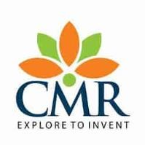

(UGC AUTONOMOUS )

Kandlakoya, MedchalRoad, Hyderabad 501401

# DEPARTMENT OF CYBER SECURITY

DATA BASE MANAGEMENT SYSTEM LAB

|  |  |  |  |
| --- | --- | --- | --- |
| Project Title | **Dispensary Database System** | | |
| Name of the | Student | Roll No | Batch No |
| 1.K.Sai Kumar | | 23H51A6224 | 21 |
| 2.D.Sai Charan | | 22H51A6278 |
| 3.D.Manjula | | 22H51A6279 |
| **NAME OF THE GUIDE** | | Mrs. Vishalini Krishnan | |

# ABSTRACT

This project develops a Dispensary Database System to make managing a pharmacy easier and more accurate. The system helps track important information like drug inventory, patient prescriptions, and transaction details in a simple and secure way. It provides an easy-to-use interface for pharmacists and staff to check stock levels, handle prescriptions, and update patient records. Features include real-time inventory updates, automatic prescription handling, and helpful reports that show drug usage and stock status. By improving how these tasks are managed, the system helps reduce mistakes, save time, and ensure that patients receive better care. Overall, the project aims to make pharmacy operations more efficient and reliable, demonstrating how modern database tools can improve healthcare services.

Signature of the Guide